Lab1 Linux
Esraa Hassouna
IOT

Q1:
done

Q2:
cat: display the file content with scroll of the screen
more: display the file content in one screen

Q3:
rm: removes empty and non empty directories
rmdir: removes an empty directory, it won’t work for non-empty directories.

Q4:1:a
when you remove the directory the inside directories will be removes, remove dir1 the entire directories will be removed.
Q4:1:b
no directory founds to be removed.
Q4:2:c
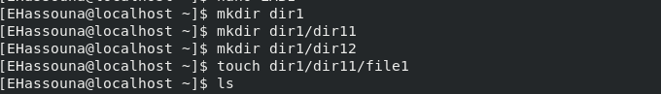

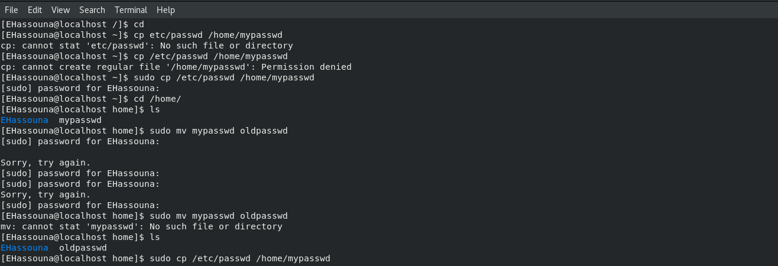
Q5,Q6:

Q7:

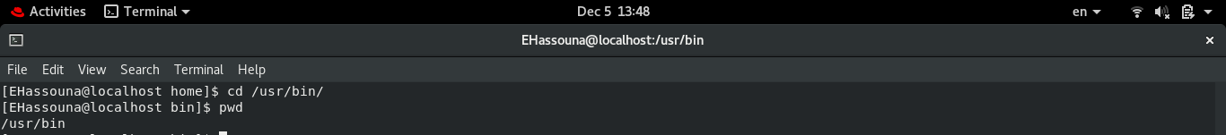

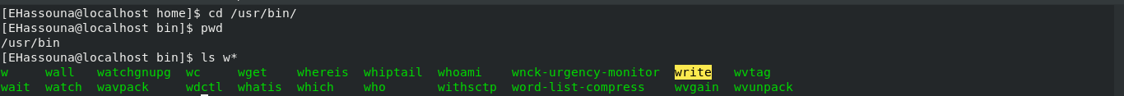
Q8:

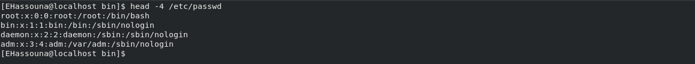
Q9:

Q10:
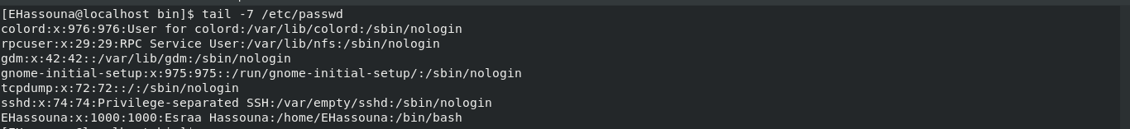

Q11:

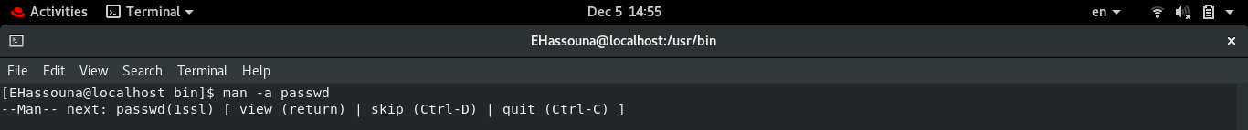
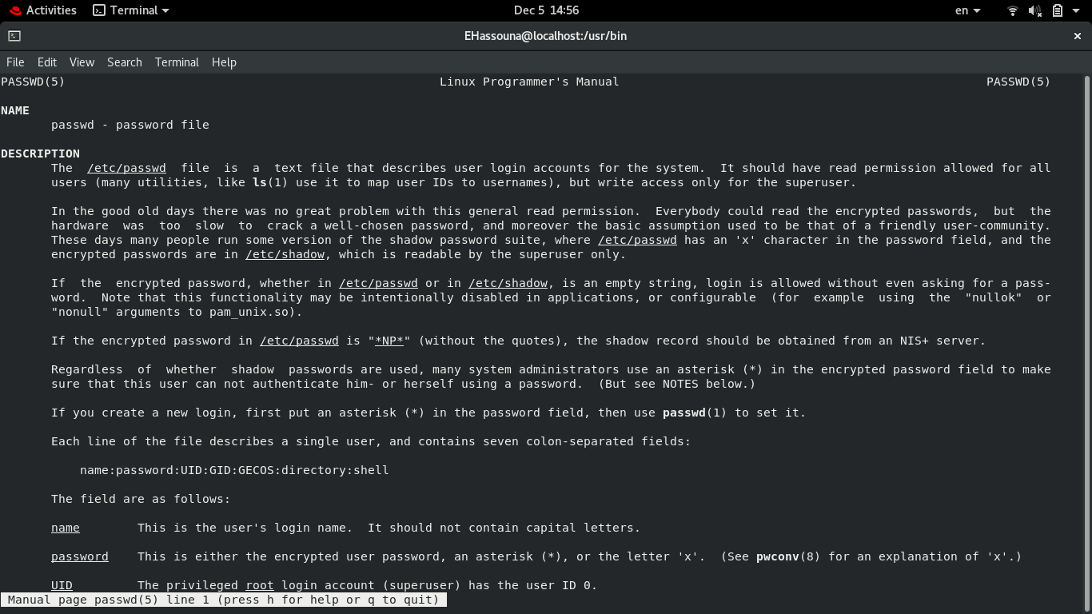
Q12:

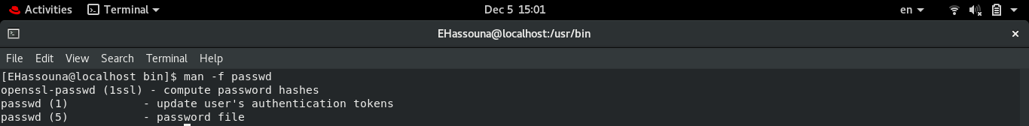

Q13:

